

Practices for Secure Software Report

Table of Contents
Document Revision History 3
Client 3
Instructions 3
Developer 4
1. Algorithm Cipher 4
2. Certificate Generation 4
3. Deploy Cipher 4
4. Secure Communications 4
5. Secondary Testing 4
6. Functional Testing 4
7. Summary 4
8. Industry Standard Best Practices 4

Document Revision History

Version | Date | Author | Comments
1.0 | June 18, 2026 | Sudarshan Acharya | Project 2 submission

Client



Instructions

Submit this completed practices for secure software report. Replace the bracketed text with the relevant information. You must document your process for writing secure communications and refactoring code that complies with software security testing protocols.

- Respond to the steps outlined below and include your findings.
- Respond using your own words. You may also choose to include images or supporting materials. If you include them, make certain to insert them in all the relevant locations in the document.
- Refer to the Project Two Guidelines and Rubric for more detailed instructions about each section of the template.

Developer
[Insert your name here.]

Algorithm Cipher

For this project, I recommend using the Advanced Encryption Standard (AES) because it is known as one of the most widely used and trusted encryption algorithms today. AES is approved by governments, financial institutions and security professionals for protecting sensitive information. Since Artemis Financial handles customer financial data, using a strong encryption standard is important for maintaining confidentiality and security.

AES is a symmetric encryption algorithm, which means the same key is used for both encryption and decryption. It supports key sizes of 128, 192, and 256 bits, with AES-256 providing the highest level of security. While AES is used for encryption, hash functions such as SHA-256 are used to verify data integrity. In this project, SHA-256 was implemented to generate a checksum value that can be used to confirm that the data has not been altered during transmission.
Random numbers play an important role in modern cryptography because they are used to generate secure encryption keys. Strong random values make it much more difficult for attackers to guess or recreate keys. Symmetric encryption methods such as AES are generally faster than asymmetric encryption methods because it only uses one key. Asymmetric encryption uses a public and private key pair and is commonly used for certificates, secure websites, and key exchange processes.
Encryption algorithms have continued to evolve as computing power has increased. Older algorithms such as DES eventually became vulnerable because of their smaller key sizes. AES was selected by the National Institute of Standards and Technology (NIST) in 2001 to replace DES and it has remained the industry standard for secure encryption. Today, AES is commonly used in secure web communications, banking systems, wireless networks and many other applications because it provides strong security while maintaining good performance.

Certificate Generation
Insert a screenshot below of the CER file.

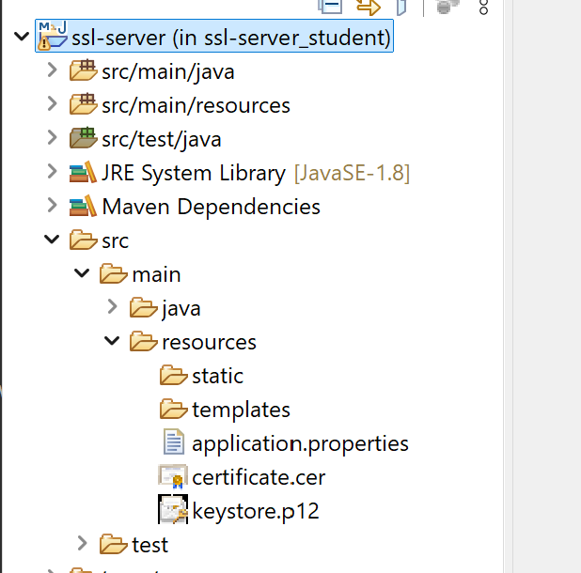

Deploy Cipher
Insert a screenshot below of the checksum verification.

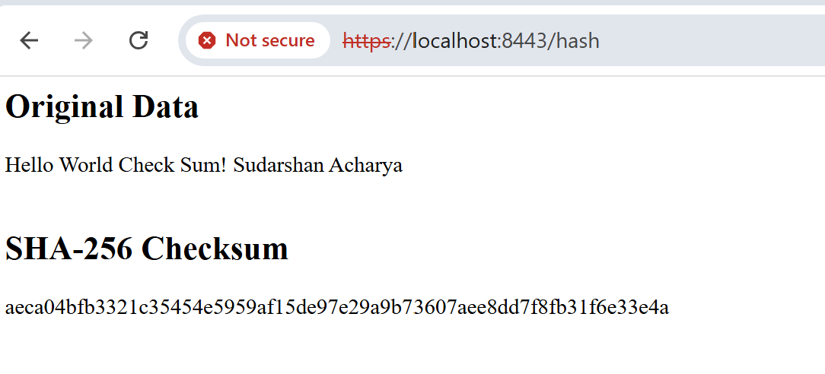

Secure Communications
Insert a screenshot below of the web browser that shows a secure webpage.



Secondary Testing
Insert screenshots below of the refactored code executed without errors and the dependency-check report.

The OWASP Dependency Check Maven plugin was integrated and executed. The tool successfully initialized and connected to the National Vulnerability Database (NVD), identifying over 341,000 vulnerability records for processing. However, the update process required a large download and repeatedly failed during the NVD synchronization stage due to the external API timeout errors (HTTP 524) and database update exceptions. I have tried multiple attempts using different versions of the Dependency Check plugin, including versions 8.4.0, 9.0.7, 12.0.1, and 12.1.0. Although the dependency-check scan was unable to complete because of NVD update and API-related errors, the application compiled successfully and executed without errors. The issue is shown in the screenshots below.
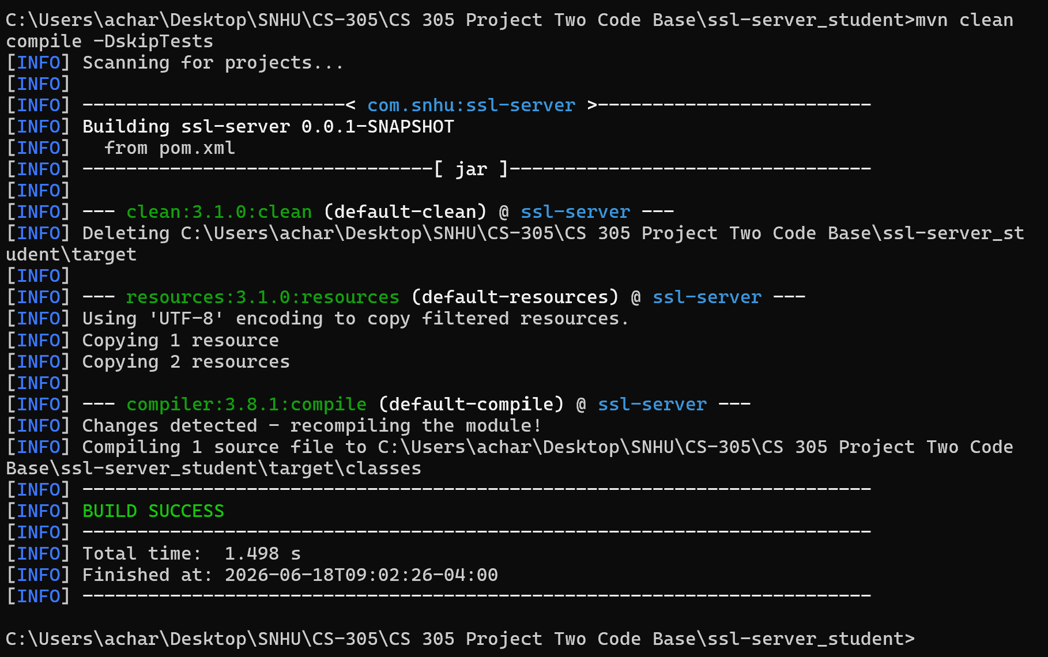

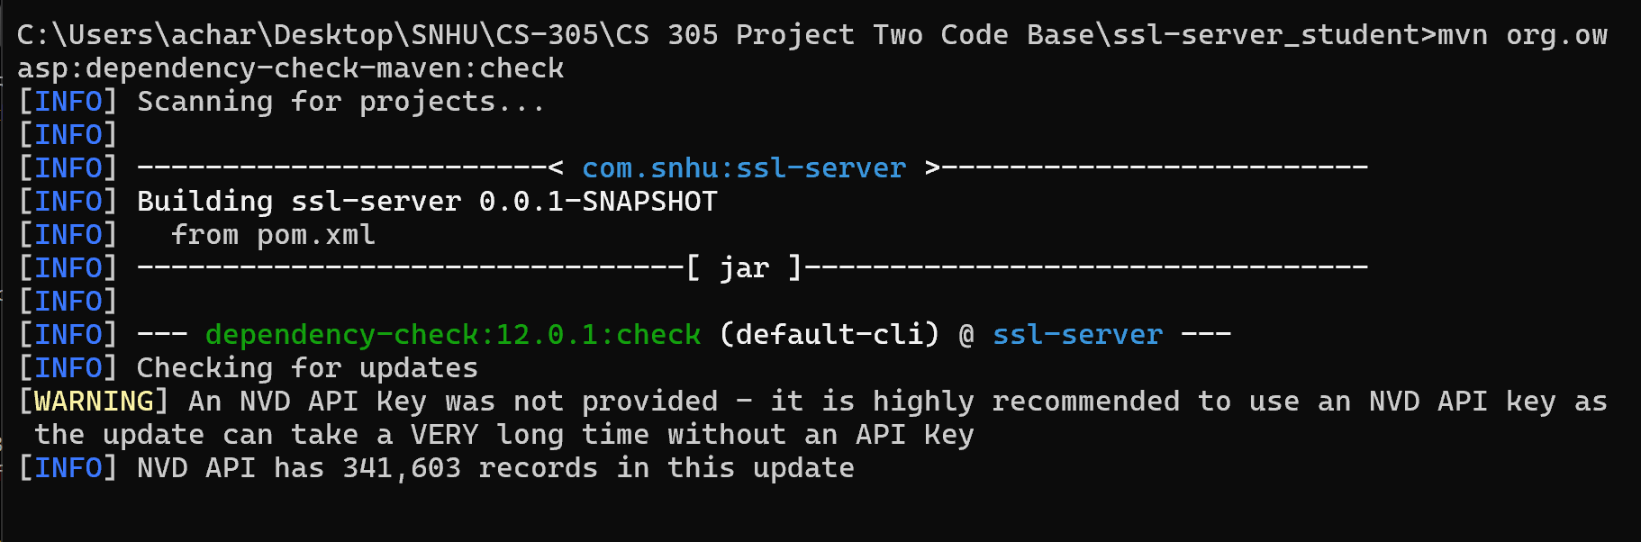

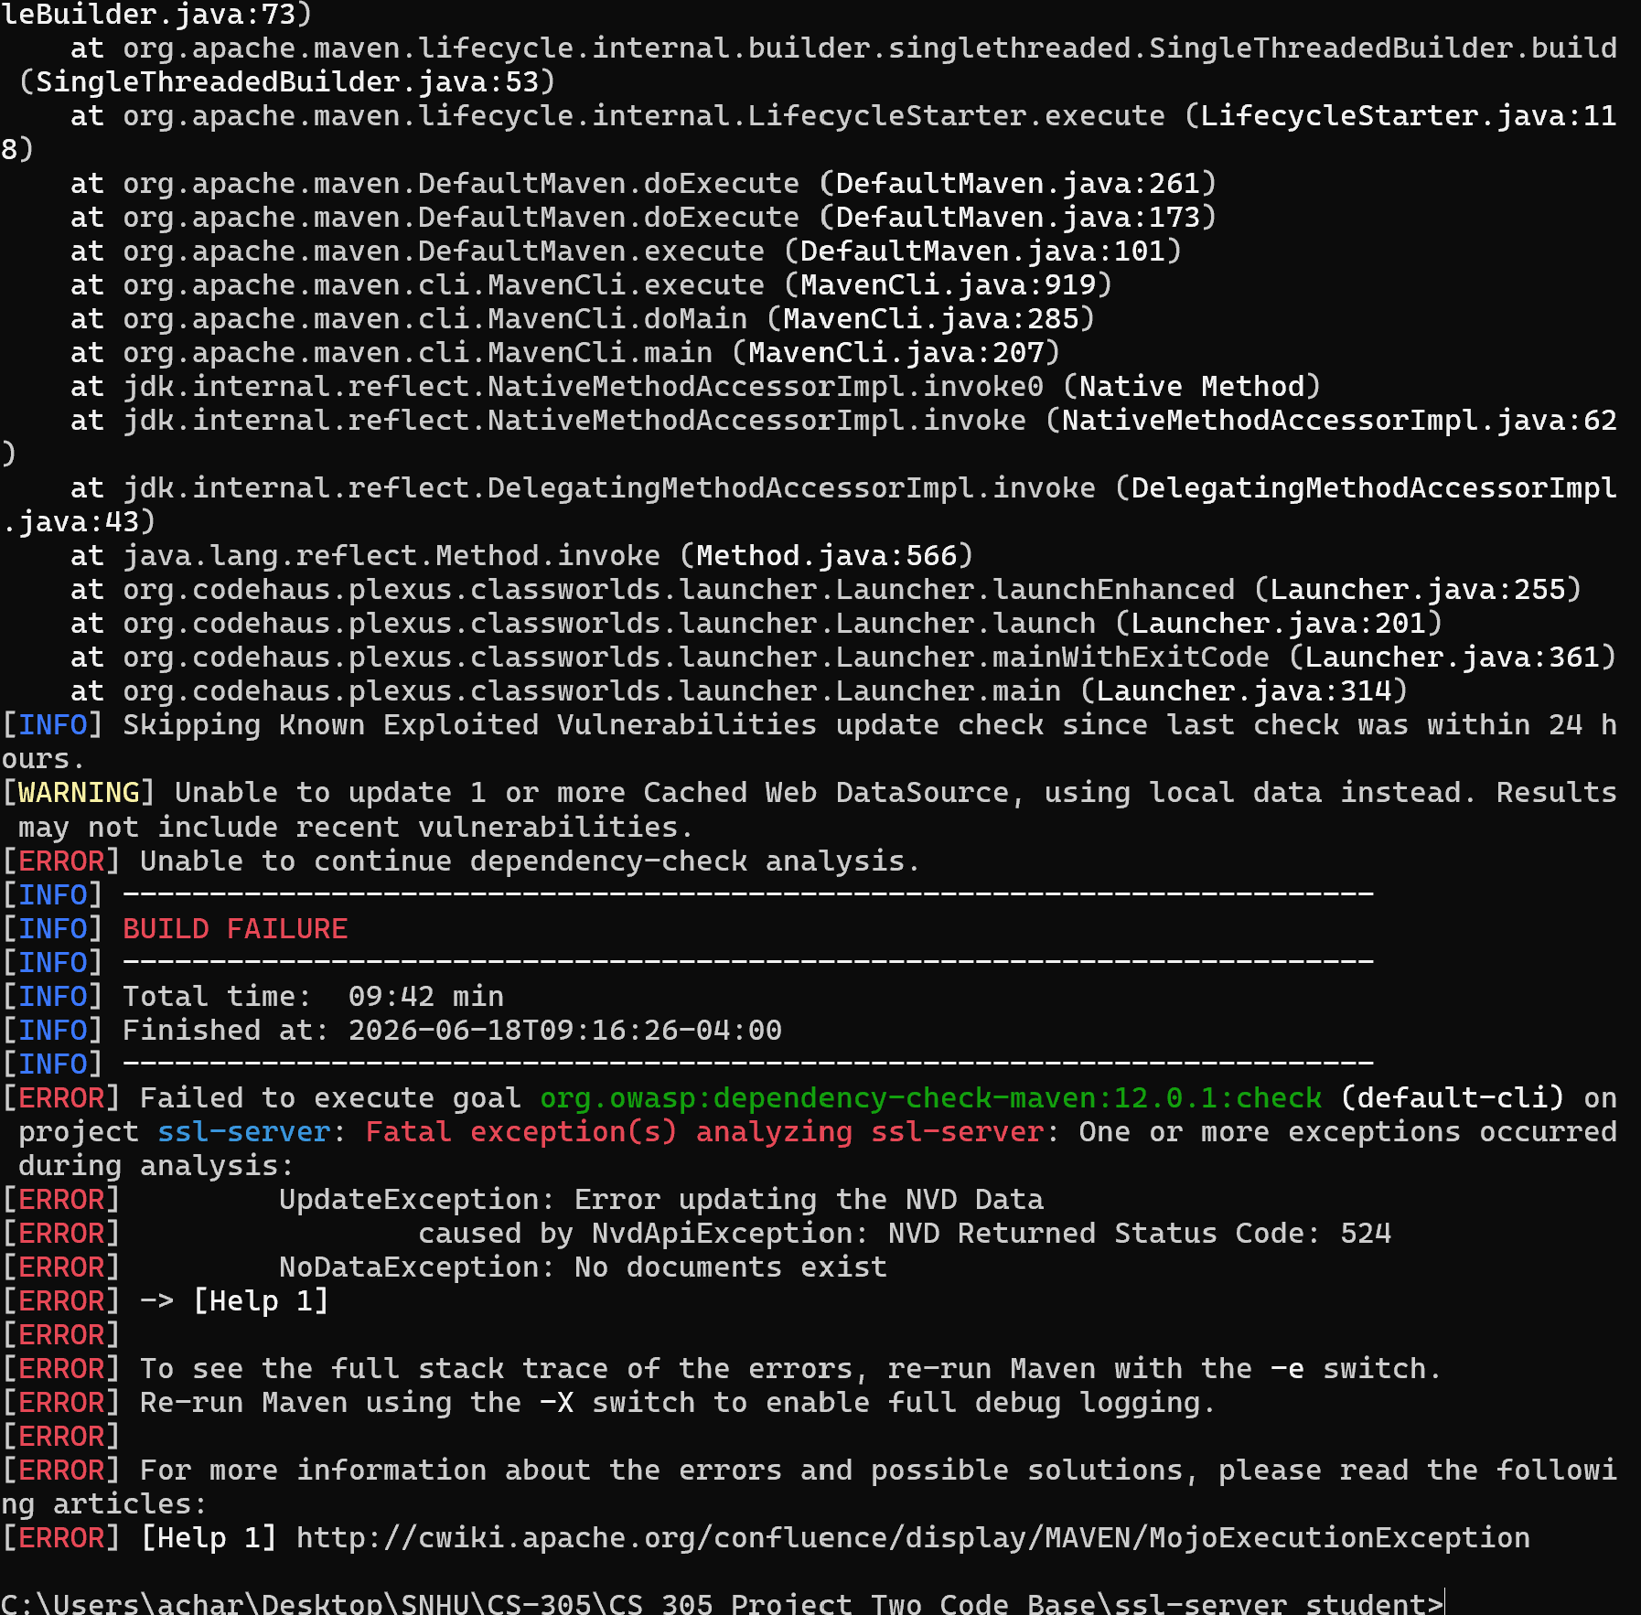

Functional Testing
Insert a screenshot below of the refactored code executed without errors.

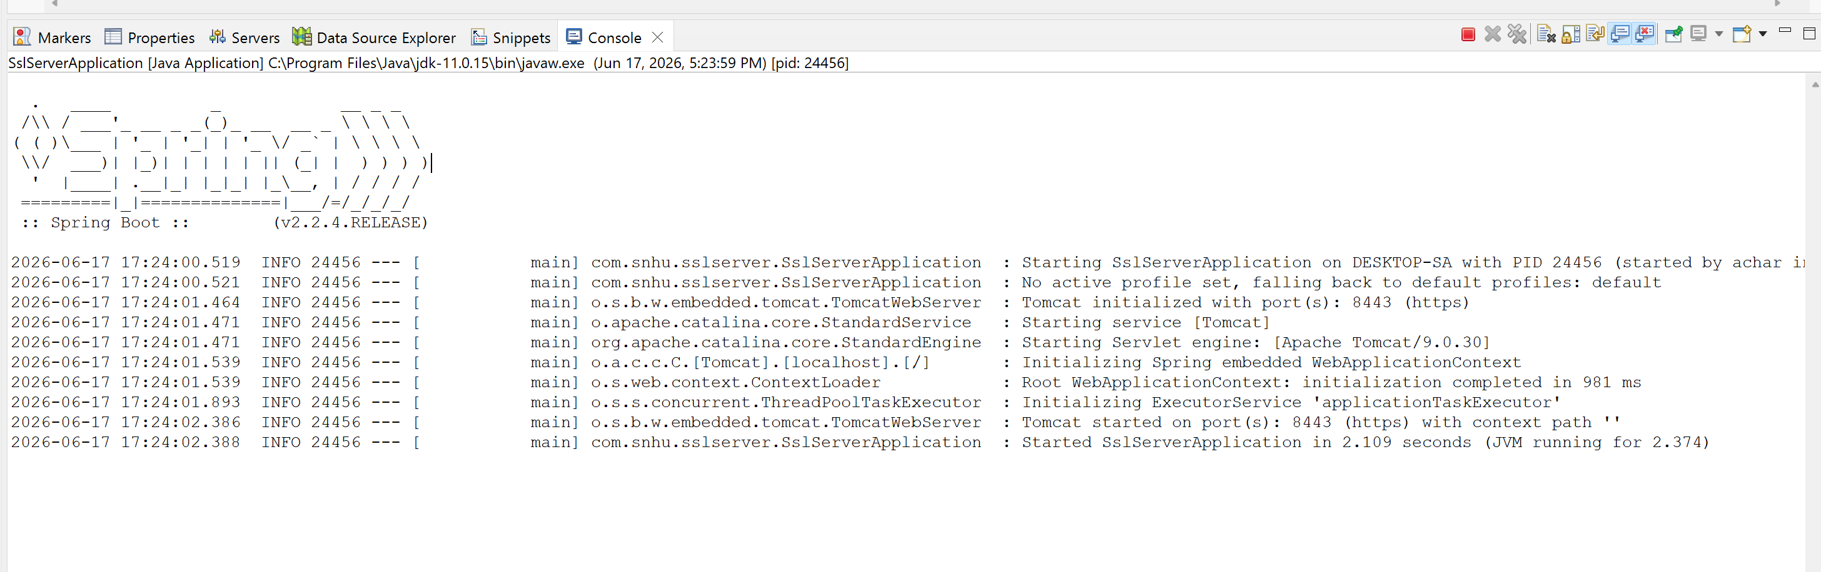

Summary

For this project, the Artemis Financial application was refactored to improve security and support the secure transmission of data. One of the main changes was implementing a SHA-256 checksum feature so that data integrity can be verified when information is transferred. Since financial information is sensitive, it is important to make sure that data has not been modified during transmission. I also generated a self-signed certificate using Java Keytool and configured the application to use HTTPS instead of HTTP so communication between the client and server is encrypted.
Several areas from the vulnerability assessment process were addressed during this project. These included secure communications, certificate management, cryptographic hashing, dependency analysis, and application testing. After making the required changes, I tested the application to verify that it compiled and executed successfully. Functional testing showed that the application started correctly and secure communication was established through HTTPS.
I also performed secondary testing using the OWASP Dependency Check tool. The scan successfully initialized and connected to the National Vulnerability Database (NVD), but the process repeatedly failed because of external NVD update and timeout errors. Even though the dependency scan could not be completed, multiple troubleshooting attempts were made using different plugin versions and configurations. Overall, the project added additional layers of security by using HTTPS, certificates, and SHA-256 checksum verification, which helped strengthen the security of the application.

Industry Standard Best Practices

Throughout this project, industry standard secure coding practices were followed to help reduce security risks and protect sensitive information. HTTPS was implemented to encrypt communications between the client and server, which helps prevent attackers from viewing or modifying transmitted data. In addition, SHA-256 was used to generate checksum values so that data integrity can be verified before it is accepted by the application.
Another best practice applied during this project was testing the application after making security-related changes. Functional testing was performed to confirm that the application continued to operate correctly after the refactoring process. Dependency analysis was also attempted using the OWASP Dependency Check tool to identify known vulnerabilities in software dependencies.
These best practices are important because they help maintain the existing security of an application while reducing the possibility of introducing new vulnerabilities. For Artemis Financial, protecting customer financial information is a critical requirement. By using secure communication protocols, cryptographic verification, certificates, and security testing, the company can improve the reliability of its software and better protect customer data from potential security threats.

References
Detlefsen, A., & Manico, J. (2014). Iron-Clad Java: Building secure web applications. McGraw-Hill Education.
Oracle. (n.d.). Java security standard algorithm names. https://docs.oracle.com/javase/9/docs/specs/security/standard-names.html#cipher-algorithm-names
Oracle. (n.d.). Keytool - key and certificate management tool. https://docs.oracle.com/javase/6/docs/technotes/tools/windows/keytool.html
OWASP Foundation. (n.d.). OWASP Dependency-Check Maven plugin. https://dependency-check.github.io/DependencyCheck/dependency-check-maven/index.html
SSL Shopper. (n.d.). How to create a self-signed certificate using Java Keytool. https://www.sslshopper.com/article-how-to-create-a-self-signed-certificate-using-java-keytool.html

